**MINEX SUMMARY**

**Model 30-29-200-B 5C4 Chassis, Borosilicate Glass, Low Vibration Cryo Mount,**

**Capacitor Board and Beryllium Copper Links**

**Vacuum Very Good Turbo running 90k rpms / 9watts, Diaphragm pump low speed (data recorded)**

**Cryo Very Good Cooldown ColdHd 65K / LNA 68K, around 182watts (data recorded)**

**X-pole Very Good Noise (5.0 - 4.0dB out to 12GHz)**

**Y-pole Very Good Noise (4.75 - 4.0dB out to 12GHz)**

**LNA RECOMMENDED BIAS SETTINGS**

**Vm + Vd must be set exactly to values below Adjust Vg as needed to get Id 24.8 to 25.0**

|  |  |  |  |
| --- | --- | --- | --- |
| **Pole** | **Minex LNA S.N.** | **Bias at Minex** | **PAM’s (HC default)** |
| **X** | **C-0083a** | **Vm -.50v / Vg 0 20v / Vd 1.20v / Id 25.0ma** | **15.0 / 15.0** |
| **Y** | **C-0084a** | **Vm -.50v / Vg -0.09v / Vd 1.20v / Id 24.8ma** |

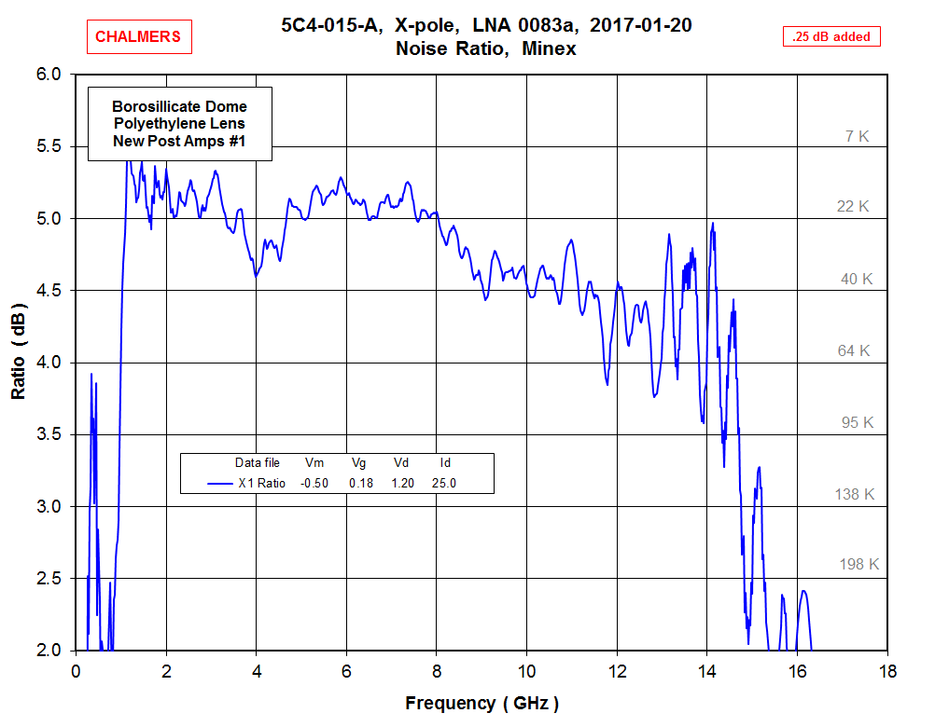

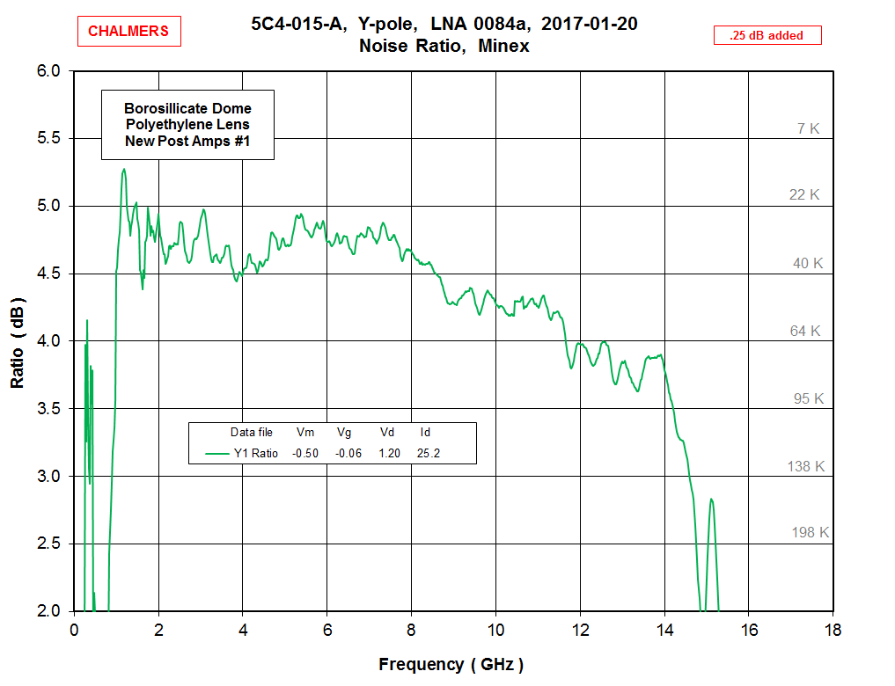

4.39” x 6.21”